Magic Ad Format Support PRD

Document Version History

|  |  |  |  |
| --- | --- | --- | --- |
| Version | Content Description | Author | Date |
| 1.0.0 | Create the magic ad format PRD | Jonny | 2020-05-12 |

# 

1 Background and Purpose **2**

2 Solution and Process **2**

3 System Changes **3**

# 

# 1 Background and Purpose

* Magic is a 3rd party vendor who can provide 3d ad format solutions based on their 3d rendering engines.
* Magic has 2 kinds of 3d rendering engines, one is based on OpenGL for native and the other is based on WebGL for web pages.
* We will select the solution with OpenGL rendering engine for in-app native ads to enhance the ads effectiveness and to improve the CTR significantly.
* We have the huge volume of in-feed traffic, but with low CTR and high CPC cost, so with this magic 3d ad format solution support, we expect to improve the CTR especially the CTR of in-feeds ads and decrease the CPC cost and ramp up the in-feeds burn.
* Below are the product deck and demo video for the 3d ad format from Magic, pls check the details:

deck:

<https://drive.google.com/open?id=1lFI72aBEQbYjKIR-bqtmMXLJRphiH0Tc>

demo video:

<https://drive.google.com/open?id=1RL-xR57EMVGuMiAHt9jUhgZwyO7ZLxwP>

# 2 Solution and Process

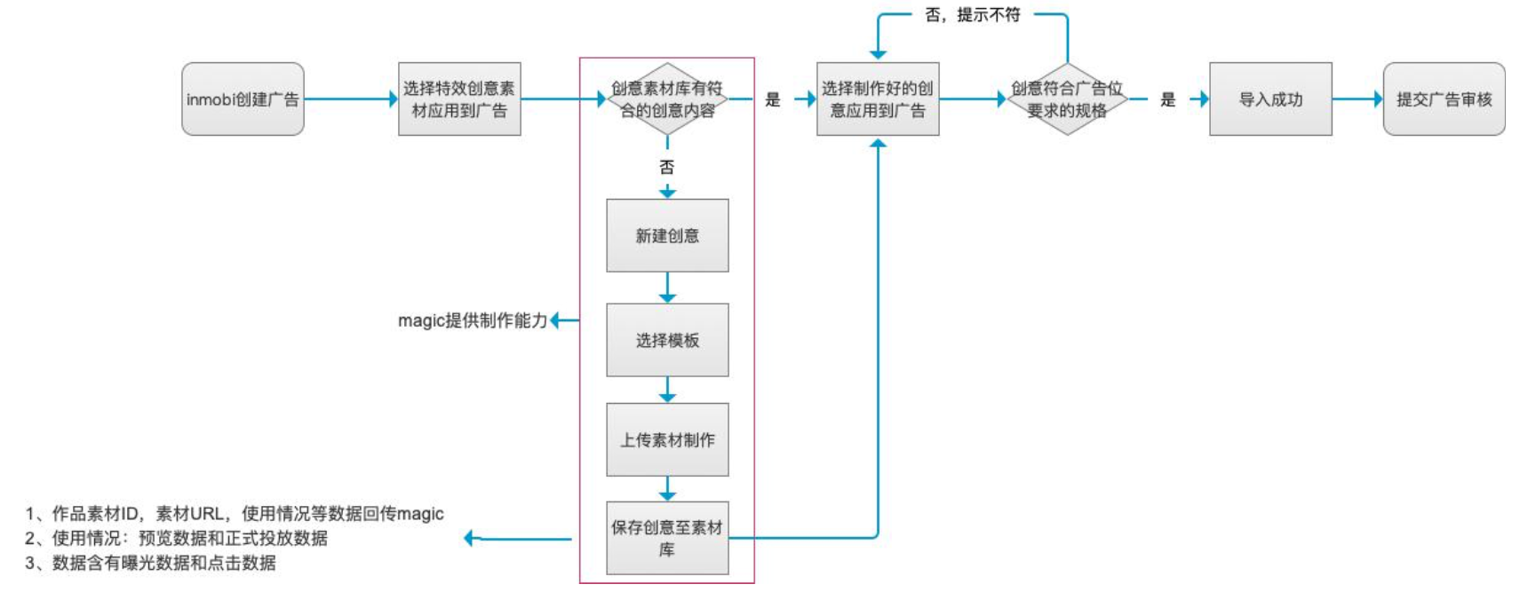

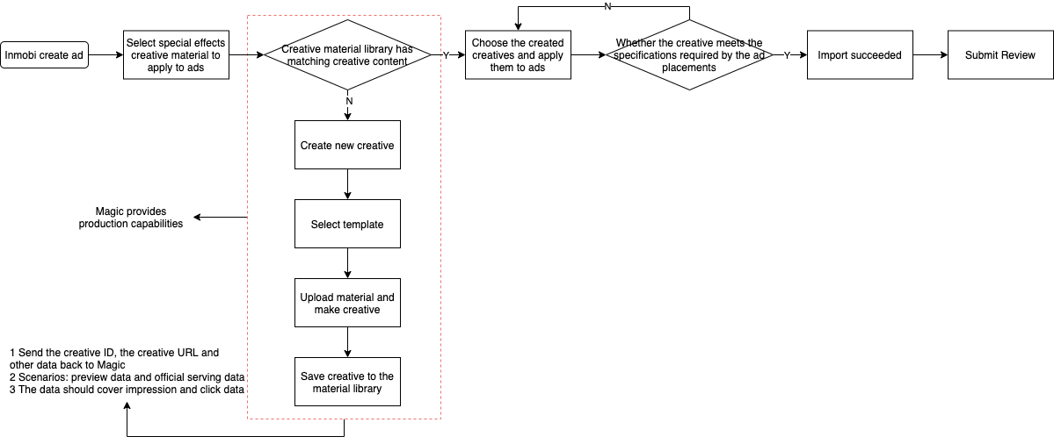

* Magic as the 3rd party vendor, will build the system to generate the 3d ads with the original creative materials uploaded from Inmobi system.
* When creating ad creatives in Inmobi ads platform, you can choose to use special effects creative materials.
* Select creative: load and display all the created creative materials in the creative material library, you can choose to use.
* Select the corresponding creative material to determine whether the material meets the specifications of the ad placement type:
  + If it matches, then check success and continue to submit ad creative review
  + If it does not match, toast prompts [the creative material does not match the type of ad placement, please reselect]
* If there is no matching creative material in the creative material library, you can jump to the creative material production platform and go to create a new creative.

Process: select template -- upload required material -- preview and save

* After the production is completed, you can return to the advertising platform to continue to use the created creative.

# 3 System Changes

Here is a summary of the discussion on the system changes among engineering guys including Amit, Ralph, Badri, Raj, Alex and Frank.

1. Treating the interactive ads as a video format, demand pools will represent these ads using CF22 schema.
2. Changes will be required in the following stacks/components:
   * CF22 schema
   * Demand ingestion (middleware, UI)
   * Ad pool(s)
   * Ad templates (for ad formatting)
   * Ad SDK
   * Supply capabilities: new supply capability for SDK version that includes support for Magic ads
3. No changes are required:
   * In UMP; UMP shall be transparent to the magic ad creative URI.
   * In ad pool request-response contract
   * In SDK-UMP request-response contract
4. Support for 3P trackers
   * All trackers should be no-JS trackers, to run Magic ads on native ad inventory
   * If all of the trackers are impression trackers, they may be handled as TPIT (third-party impression trackers) trackers
5. Execution sequencing shall be:
   * High-level design to flesh out changes to CF22 schema, ad pools handling
   * Ad-SDK changes (ongoing work continues)
   * Ad pool changes
   * Creative ingestion via DB-RFC (to avoid blocking on UI + demand service changes)
   * E2E to verify overall ad experience, tracking, fix bugs in ad pools, SDK, etc.
   * Demand ingestion middleware + UI changes
   * Scale product with self-serve capability to create/ingest Magic ads for CMs